Work report 29 july 2021

Today I have checked the performance of pp yolo on test dataset.

Graphs for precision and recall of all the classes are as follows:

<https://drive.google.com/drive/folders/1Rv99vm4CShutPIDZNkHXQaybkzbjLzuT?usp=sharing>

In this the Traffic light is shown as Nan.

But when I tried to check the detection on traffic light it was quite well.

<https://drive.google.com/drive/folders/10tx-pTx5hX_3lVszTGP4-Iv6idtxCb41?usp=sharing>

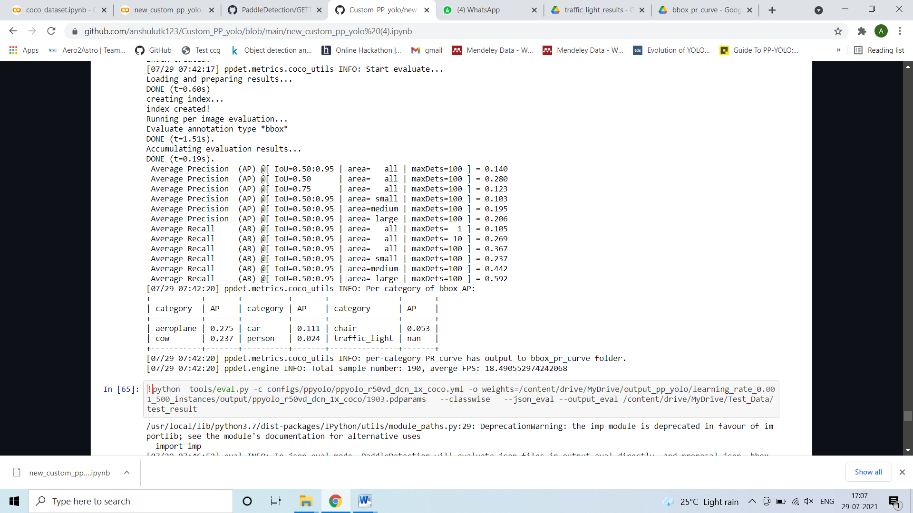

The code is uplaode on github :

<https://github.com/anshulutk123/Custom_PP_yolo/blob/main/new_custom_pp_yolo%20(4).ipynb>

Next I am going to do the same for YOlO v4 model and currently doing that.